Nicholas Ang

CS457

Project Assignment 3

PA3 Design Document

The JOIN operations for both inner join and left outer join were done using nested for loops. The outer for loop loops through the rows of the first table while the inner for loop loops through the rows of the second table. The joins were implemented with only equality comparisons so if only works for where table 1 value equals table 2 value or on table 1 value equals table 2.

Pseudo code for a join would be:

for each row in table 1

for each row in table 2

check if values are the same

The inner join combines the two tables of table 1 and table 2 and outputs a table to the terminal with the combined attributes of both tables and records where the join condition is satisfied. If the join condition is not satisfied, the combined record is not added to the joined table.

The left outer join has similar functionality to the inner join but added unmatched records from table 1 to the joined table. It combines table 1 and table 2, and if it matches, the record from table 1 is joined with the record from table 2. If there are additional records that do not match from table 1, it is added to the joined table with the table 1 record joined with the NULL values from the table 2 record.

**Execution Instructions:** Please use the command *g++ p3.cpp -o p3* to compile the program and mainly use *./p3 PA3_test.sql* to run the test script with the program. If you want to test some commands, use the command ./p3 to start interactive mode. Interactive mode requires proper spacing in the command to be entirely correct for commands to work so follow the format of the commands in the test script.

The image below shows the output in the terminal when the test script is run with the program.

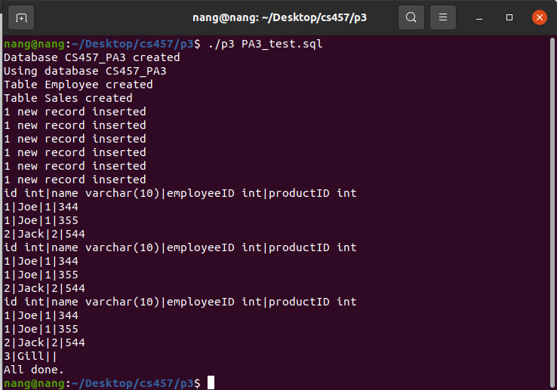

The image below shows the output in the terminal when the user inputs the commands one by one into the program in Interactive Mode.

